**Assignment 1**

***When to Submit***

*Due: 11:59pm, 1/13/2021*

***What to Submit***

*Put your Python functions in a single .py file. Please ensure your codes are executable without errors. Clearly document it.*

***How to Submit***

*Submit all your code and pdf file using the CCLE.*

**Part I: Reading Assignment *(0 Point)***

You are required to study the Lecture0_Python.pptx before moving to the Part II. Please read through this powerpoint. Copy/paste all the coding lines to your own Python editors and execute them. Ensure to execute the running examples by the end of the file, and complete the coding lines if needed.

**Part II: Coding Assignments**

1. Write a Python function that takes a positive integer N and returns the factorial of N, i.e., N!

The factorial of N, denoted N!, is the product of the integers from 1 to N. *(1 Point)*

Examples:

5!=5*4*3*2*1,

4!=4*3*2*1

0!=1

2. Write a short Python function that takes a sequence of integer values and determines if there is a distinct pair of numbers in the sequence whose product is odd. *(1 Point)*

Examples:

Inputs: 2 4 5

Outputs: false

Inputs: 1 3 4

Outputs: true

3. Write a python function that takes an integer (e.g., 342, -123) and returns its reverse digit (i.e., 243, -321). *(1 Point)*

Examples:

Input: 234

Output: 432

Input:-241

Output:-142

Notes: This function should be able to deal with both positive and negative integers.

4. Write a Python function that takes a string s, representing a sentence,

and returns a copy of the string with all comma removed. *(1 Point)*

Examples:

Inputs: “Sit down, please”

Output: “Sit down please”

Input: “Hello Python, I don’t really know you well”

Output: “Hello Python I don’t really know you well”

5. Given a string s containing just the characters '(', ')', '{', '}', '[' and ']', write a Python function determine if the input string is valid. *(2 Point)*

An input string is valid if:

1. Open brackets must be closed by the same type of brackets.
2. Open brackets must be closed in the correct order.

You don’t need to worry about time complexity nor storage complexity.

Examples:

Input: s=”()”

Output: true

Input: s=”({})”

Output: true

Input : s=”(}”

Output: false

Input : s=”([{})]”

Output: false

6. Write a Python function that merges two sorted lists and return a new sorted list. Both the input lists and output lists should be sorted. You might use the Python list as the data structure. *(2 Point)*

Examples:

Input: 1<3<4, 1<2<6<8 （[1，3，4]，[1， 2，6，8]）

Output: 1<1<2<3<4<6<8 （[1 1 2 3 4 6 8]）

7. In python, the library [matplotlib.pyplot](https://matplotlib.org/api/pyplot_api.html#module-matplotlib.pyplot) is a collection of command style functions that make matplotlib work like MATLAB. Each pyplot function makes some change to a figure: e.g., creates a figure, creates a plotting area in a figure, plots some lines in a plotting area, decorates the plot with labels, etc. In [matplotlib.pyplot](https://matplotlib.org/api/pyplot_api.html" \l "module-matplotlib.pyplot" \o "matplotlib.pyplot) various states are preserved across function calls, so that it keeps track of things like the current figure and plotting area, and the plotting functions are directed to the current axes (please note that “axes” here and in most places in the documentation refers to the *axes*[part of a figure](http://matplotlib.org/faq/usage_faq.html#parts-of-a-figure) and not the strict mathematical term for more than one axis). *(2 Point)*

Sample Codes:

**import** **numpy** **as** **np**

**import** **matplotlib.pyplot** **as** **plt**

ax = plt.subplot(111)

t = np.arange(0.0, 5.0, 0.01)

s = np.cos(2*np.pi*t)

line, = plt.plot(t, s, lw=2)

plt.annotate('local max', xy=(2, 1), xytext=(3, 1.5),

arrowprops=dict(facecolor='black', shrink=0.05),

)

plt.ylim(-2,2)

plt.show()

Outputs:

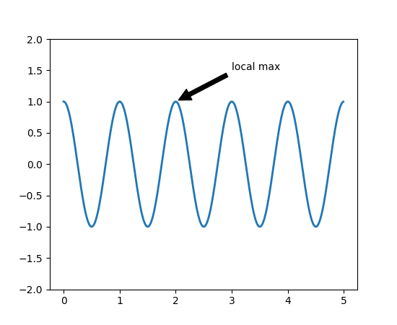

Please select a proper range for the variable x, and write a python function to visualize the following functions:

* Straight line $y=θ_{0}+θ_{1}x$ where $θ_{0}=30, θ_{1}=0.5$
* Quadratic function: $y={\left(x-θ_{1}\right)}^{2}+θ_{0},where θ_{1}=25, θ_{0}=20$
* Log function, $y=-\log\left(x\right)$ and $y=-\log\left(1-x\right)$,
* Sigmoid function, $y=1/(1+e^{-x})$

Note that you should select a set of proper values for x, calculate the corresponding y values and plot (x,y) pairs. Please include your code in the .py file and submit a .pdf file to include all the plotted figures.